**Generative Arts and Musical Machines Project Journal: RIFS**

**Introduction**

This is the Project Journal for the Generative Arts and Musical Machines Module.

**Week 1**

Having previously read through all of the module information, I’m very intrigued by this module. I think it is going to be really interesting to see everybody’s machines at the end of the module because they can be so varied depending on the angle they start from. Furthermore, there’s an element of mystery surrounding how they will all interact.

Immediately, I know I don’t want my robot to cause a problem in this interaction. I want my robot to be able to integrate and work with any kind of robot musical ensemble. For this to happen, I think a good premise at this early stage to not relying too heavily on specific musical input or rules. All of the robots will have some kinds of sensors to interact with each other, e.g., microphones, UV sensors, light sensors etc. If a robot relies too heavily on expecting one kind of input or range of data, it can make it quite inflexible.

In the lecture we looked at ideas of bottom-up composing which actually seems to benefit people who know less about music, they can grow simple rules into something complex. They don’t need to have the widest understanding of music theory as say they would do in a Top-Down approach. This is more democratic.

I had some ideas about my robot. It could react to perceived volume in the environment. How might it change when the volume gets louder or quieter? Does it overpower other robots when they are quiet, or does it wait for lulls in the music to get louder like a soloist waiting their turn?

Inspired by Ben Burtt’s creation of the lightsabre sound <https://www.youtube.com/watch?v=tZj1mYLC7h0> (Accessed: 2 October 2022) one initial idea I had was using old tube technology or hacking other hardware and potentially inducing sound on a moveable microphone.

Also, I could make use of spectral analysis.

Notes from research

* Ideas of if the robot is accompanying or should be accompanied – is it supportive or the main thing?
* Improvisation within a form – possible as parameters of a form can be defined or intuitively created e.g., upon input – other robots may have to know the limitations of the system.
* Doesn’t need to be traditionally musical – mammoth beat organ – can have percussion + repeated notes.

**Week 2**

I was introduced to the teensy, the microcontroller which I would use to make my system. This was useful because through the coming weeks I would get to know the benefits and limitations of the technology. This would help me decide on my project.

I was also made aware of the 3D printing capabilities at the university. This increased the possible scope of my project as I knew I was not constrained by finding or working around specific parts.

One idea I had for my project was a piece of sonic automata that would play the drums, woodwind, or brass. I thought it would be interesting to explore these instruments past the limitations of the human body playing them. For example, extremely fast drumming using actuators or on brass/woodwind playing unnaturally fast notes with no need to stop to breath. Furthermore, I could write a program to absorb/rip and use rhythms generatively for example from a J Dilla mix <https://www.youtube.com/watch?v=ctHqgoxQ2Mo> (Accessed 6 October 2022). Through use of sonic automata these instruments could really be pushed to the limits and creatively explored.

**Week 3**

Inspired by the improvisatory systems of Ajay Kapur and Shimon I had to idea to create a robotic jazz bass improvisatory system that could be useful to practice with for other instrumentalists. At its base level it would use beat and key detection along with a library of patterns such as 1,3,5,3 to play basslines adjustable to any key. The library of base patterns would contain variations of each pattern. Software would also be used to vary these base patterns adding double notes, drops and run downs efficiently avoiding the need for massive amounts of patterns in the library. At a more complex level sensors(microphones) along with spectral analysis would be used to identify specific rhythms and notes to emphasise or change what is played in other ways.

However, despite this being an interesting project, I realised it was out of scope of the module as it focuses more towards playing with humans rather than other sonic automata. Nevertheless, I realised that anyway I wanted to make a unique piece of sonic automata something that doesn’t just act to replicate humans. I wanted to explore what the technology could create that was unique.

**Week 4**

In week 4 my research led me to the sonic kinetic art installations of Zimoun. I thought these were amazing. The use of robotics to create sonic art that would have been practically impossible to do with humans in such a controlled way was inspiring and really seemed like something new on the frontier of creativity. This reinforced my previous decision to create something unique to the possibilities of creative robotics.

Monumental to my project was the discovery of Dylan Sheridan’s ‘Random Impulse’ the aesthetic of the microphone being projected around the room seemed so original. I immediately knew I wanted to take a lot of inspiration from this. The project seemed to encapsulate the unique creativity I wanted to explore.

**Week 5**

Now I knew I wanted to use robotics to project a microphone around a room, I thought about how I could build on and have an original take on this idea. With the inclusion of the microphone in the system I thought that by introducing other speakers I could do some interesting things with feedback especially given that the microphone was moving. I decided on this idea because I was really intrigued by the potential results.

I started thinking about how I was going to do this. Despite conceptually drawing a lot of inspiration from Sheridan, I wanted to forge my own path in my methodology. I started researching how I would propel the microphone. My first idea was to create a pulley-based catapult system which I would rotate using Servo’s. I researched into catapult systems <https://www.youtube.com/watch?v=Bur7Bcdw-vg> (Accessed 5 November 2022). <https://www.youtube.com/watch?v=jTBDc19eW2o> (Accessed 5 November 2022). However, I soon realised a problem with this. Catapults only propel something in one direction, therefore for it to propel the microphone one way and then the reverse direction it came from it would have to reset the microphone and rotate the base 180° before launching again. This is going to take too long to create the dynamic kind of movement I want in my system.



Looking at the trebuchet <https://www.youtube.com/watch?v=jTBDc19eW2o> (Accessed 5 November 2022) got me thinking. The reason it needs such a large counterweight is because of the weight of wooden arm and the stone missiles it throws. If I could make the arm section and microphone light enough, one point of rotation controlled by a motor will work. This most importantly will allow the capability of rotating back and forth (left or right) and quickly.

**Week 6**

I know I’ve got my presentation due in next week, so I continued working on planning my project. Regarding the speakers in my system, I knew I wanted to have an array in a circle around and facing the microphone. This seemed like the best configuration as it essentially surrounds the microphone with speakers meaning there will almost always be applications of feedback. Initially, I had wanted to use eight speakers spaced at 45° intervals around the circle however ultimately, I decided on four spaced at 90° intervals. This would be much more practical to set-up and move around whilst still remaining effective. Furthermore, this decision was also reached due to contemplation on signal flow as I decided I would be using my Scarlett 6i6 Audio Interface to send signals to the speakers. This piece of hardware has 6 outputs.

I was happy with how my project coming along but I realised it was missing something. This is going to be part of a robotic orchestra and I want it to really interact with the other instruments and be part of a bigger system not just act independently. Firstly, I need some outward sensors to get some input data of what is occurring outside my system and this needs to have some sort of effect on my musical robot. Given the context of my feedback system, I immediately had the idea to use outward facing microphones as sensors and inputting this sound into the feedback system. The sound from other sonic automata will be the base sonic material fed into my system. This is actually a very high level of interactivity because I’m not just using one element of sound such as speed or rhythm or identifying pitch, the whole sound of the robotic ensemble timbre and texture included will have a very large impact on the sounds eradiating from my system.

To tie the elements together in a system logic, I decided that the outward facing microphones input into a Max patch should be used to identify what direction surrounding RIFS the loudest sounds are emanating from at specific time intervals, the teensy microphone should then be projected in that direction. This should create interesting and dynamic movement and feedback and be especially interesting in a room with other sonic automata spread throughout the space.

Given this logic I now knew I needed the functionality for the microphone to be projected to four discrete locations, the four different speakers.

**Week 7**

Following on from last week, I focused on how I was going to project the microphone to these four locations. We had used Servo’s in previous weeks controlling them via the Teensy and Arduino IDE software so I knew they would be useful for this. I numbered each of the required positions 1-4.

1

4

2

3

I already knew I would have one servo connecting the base of arm to a frame that could move it in one plane from left to right, hitting two positions. For example, 1 and 3. However, then I decided I would connect this frame to another servo and rotate it 90° to access the other plane when necessary. The bottom servo rotating the frame will be referred to as Servo1 and the top servo rotating the arm Servo2.

The logic will flow as such:

Initially upon receiving a new position to action from Max/MSP Servo2 moves to a neutral 12 o’clock position or 90°.

If the new position is 1 or 3, Servo1 moves (or stays at) to 0°.

If the new position is 2 or 4, Servo1 moves (or stays at) to 90°.

If the new position is 1 or 2, Servo2 moves to 0°.

If the new position is 3 or 4, Servo2 moves to 180°.

Servo2

Arm

Thin Wire

Frame

Microphone

Speaker 3

Servo1

Speaker 1

The diagram above shows a side view when Servo1 is at 90°. The arm will be made out of somewhat flexible material to allow some bend as it moves and rests in each position. The microphone shown will be a teensy microphone (PUI Audio part AOM-6738P-R). This is because I need it to be lightweight as already explained to work with Servo2. Furthermore, this choice is functional because the quality of the signal is not that important due to its function to simply produce feedback. The signal from the teensy microphone will be output through all the speakers.

For the presentation I also worked on a proof-of-concept video. I decided to create something linking the teensy hardware which I would have to use i.e., the microphone and a servo. I created code which moved a servo in relation to sound level recorded by the microphone. The louder the signal the more the servo rotates away from 0°. In essence I scaled the root mean squared value of the microphone signal between around 0-180. I then wrote this angle into the servo.

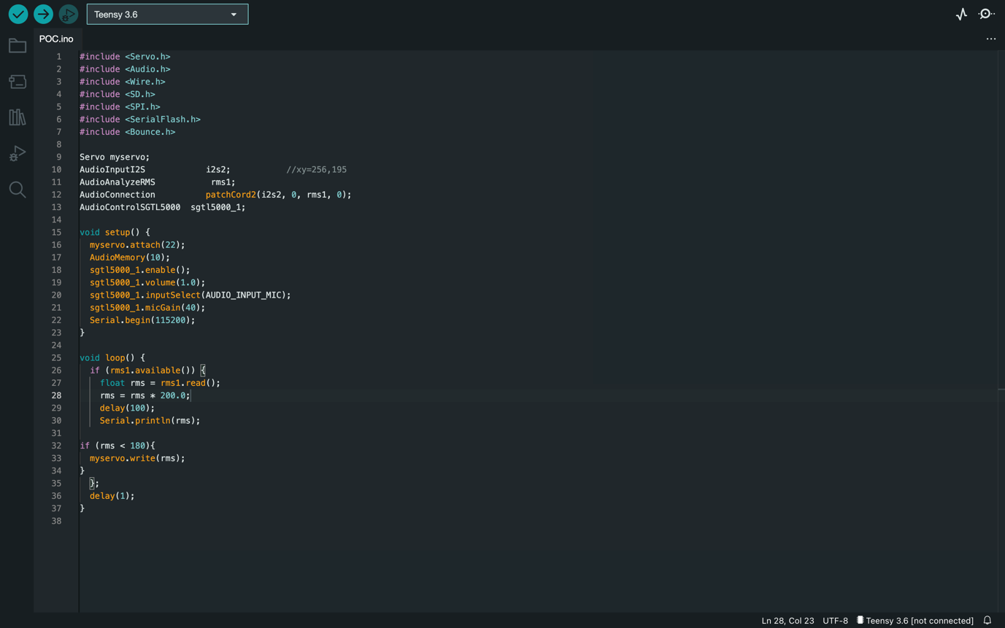

A quick note on signal routing and outward microphone placement. I decided I would use four outward facing microphones each placed next to a speaker and the signal from each microphone would be output through the speaker it is positioned next to. This should be interesting as each speaker/microphone pair works independently.

Also, I haven’t yet mentioned once this part of the base part of the project is completed, I will use Max to create code to stop unpleasant and uncontrollable feedback peaks and potentially use frequency detection and subsequent equalisation to tame some of these peaks.

Also, I had the idea to modulate the main (outward microphone) signals using the teensy microphone signal. Furthermore, I could add an accelerometer to the teensy microphone and use its data for further processing such as filtering etc. However, both of these ideas are something I will have to experiment with once the system is set up.

**Week 8**

N/A

**Week 9**

I started thinking about the hardware that I am going to use for my project. It was suggested that I could find some old computer speakers however I eventually opted to rent out some more powerful monitor speakers. I am using one pair of Genelec 8020C’s and one pair of Genelec 8030’s. Despite the slight size difference, they are very similar and through their use I benefit from a uniformity across my system.

Next, I worked on creating the arm. I knew I wanted it to have some elasticity to add some generativity and variation in its movement. I created it by twisting together 3 or 4 pieces of wire, this had the added benefit of being extremely light. As it has this elasticity it will never move in exactly the same way as would a completely ridge arm for example. This is exactly what I want in my piece of sonic automata, because of the variation it will be more interesting over extended listening periods. Furthermore, this generativity is even more important given my limited four discrete positions which are actioned by the servos. The inclusion of the teensy microphone hanging by a very thin wire adds to this generativity as it will arc through the air and hits the floor and potentially the speakers themselves.

The negative aspect of this wire arm is that it sometimes loses its shape too much and it requires maintenance to twist out more for optimum performances. This being said, the choice is definitely worth it for the variation it will add to the system. Also, throughout a performance it morphs in a form of physical data feedback. If one position is more common the arm might bias towards that shape.

I also built the frame that will connect the two servos. I did this using malleable lightweight metal wire. This is a much more rigid material than used for the arm but is still flexible and compounds the benefits of generativity discussed in relation to the arm. I bent the wire into a rectangular shape.

Also in this week, I decided against the inclusion of an accelerometer in RIFS. This is because I didn’t want to add extra weight onto the arm. Furthermore, it was somewhat unnecessary, there is a lot I can do with just feedback.

After that, I worked on testing the servos. I had a few SG90 Servo motors, and I needed to make sure that they were powerful enough to move the different components of my system. Upon testing with the arm and frame (primitively attached using cable ties) I knew that they would be strong enough. If they weren’t I would’ve had to access some larger more powerful servos.

**Week 10**

I fixed the arm to Servo2 using gaffe tap.

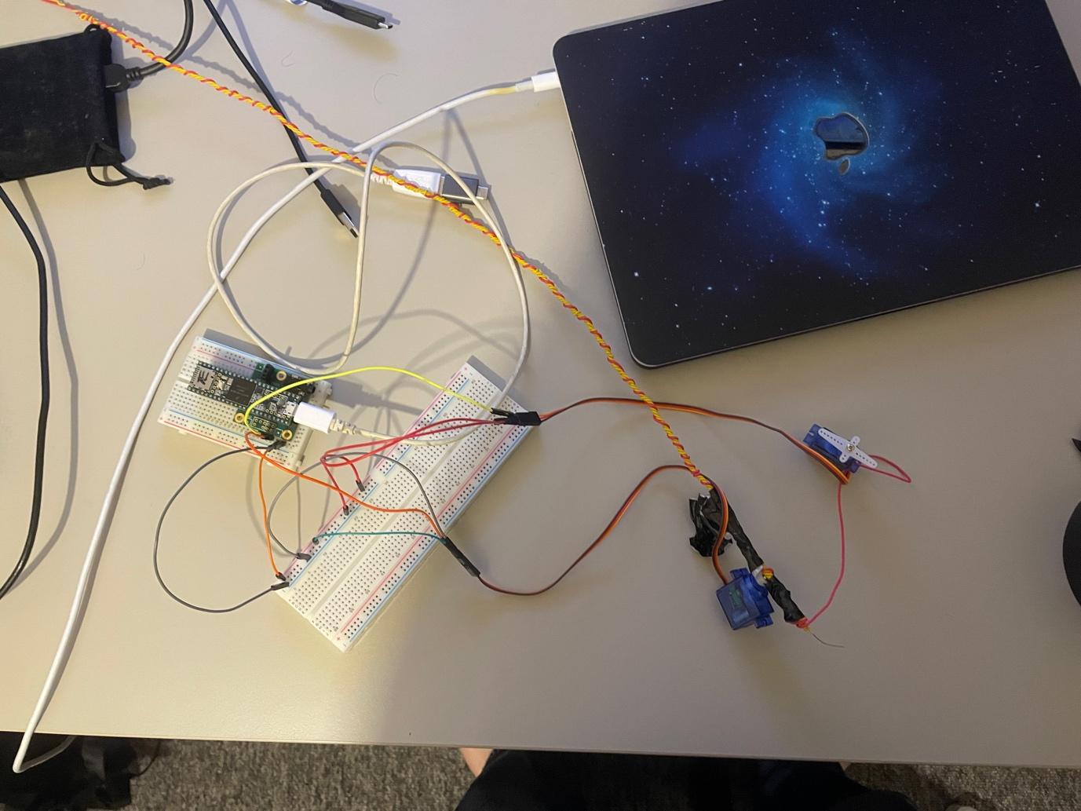

I then wrote code to test the two servos at the same time. To annotate the picture shown above, due to the fact both the servos need 3.3 volts and ground connections, I have connected power and ground signals into the bread board via patch cables. I then connected the power and ground side of the breadboard into the servos red and brown cables respectively. I then connected the PWM orange connections into digital pins (Servo1 Digital Pin 21, Servo2 Digital Pin 19).

I did some research into other people using teensy to control multiple servos at the same time (<https://forum.pjrc.com/threads/61696-Controlling-Multiple-Servos-with-Teensy-3-6> Accessed: 28 November 2022). However, the code needed was fairly simple.

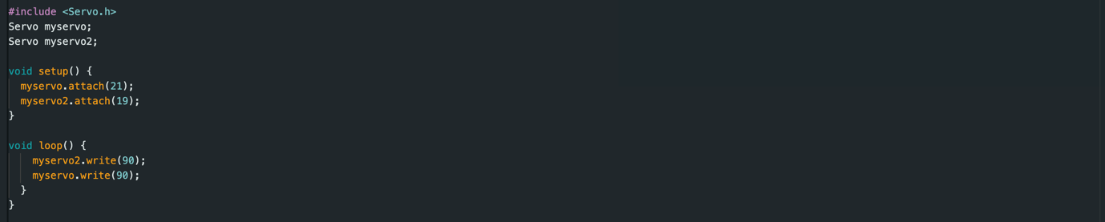

The next thing I needed to do was to get the teensy microphone input into Max/MSP. In my proof of concept, it was all contained within the teensy and Arduino software. For RIFS I am effectively using the teensy as an audio interface and researched how to do this.

This blog was helpful: <http://openaudio.blogspot.com/2016/10/teensy-audio-over-usb.html> (Accessed: 29 November 2022). I generated code using the web design tool.

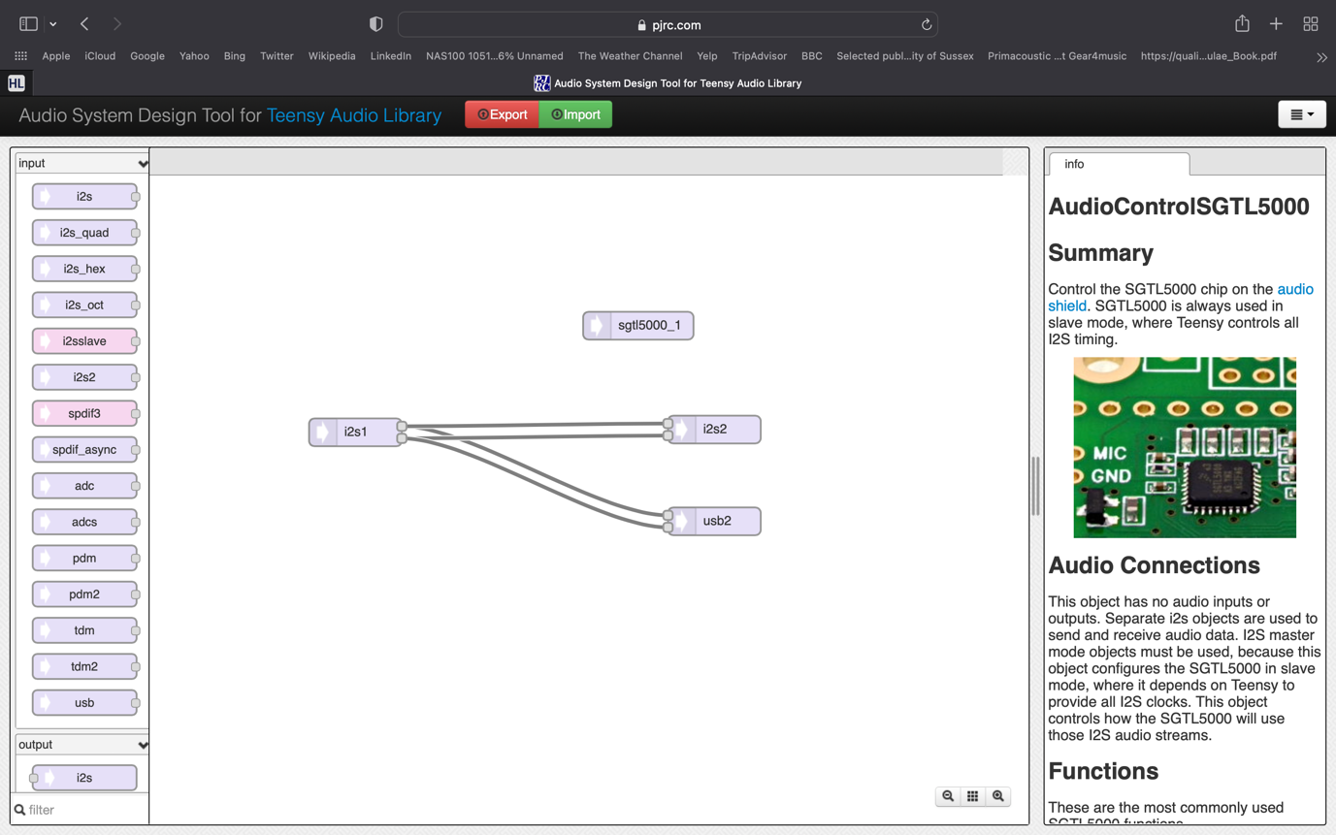

This sets up connections to allow me receive audio (i2s1) from the Teensy Audio Shield which the microphone is connected to and send this out through the USB port (usb2). ‘i2s2’ output also allows me to listen to sound through the headphone jack, a functionality which may be helpful in testing and isolating problems. I used the code below which was generated when I exported the patch.

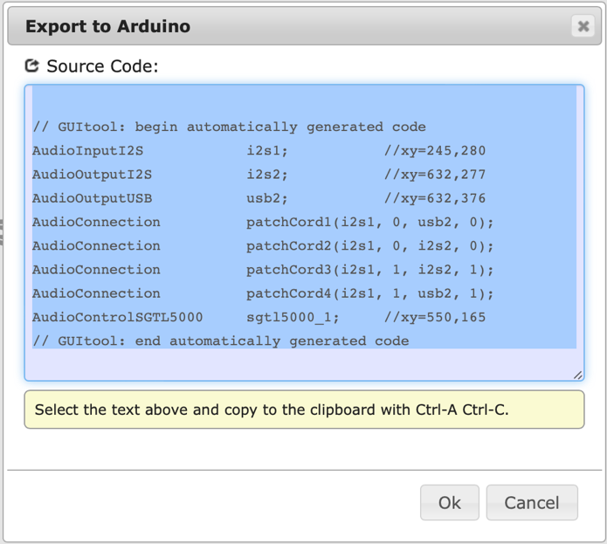

I also incorporated basic microphone set-up code from the ‘1_TeensyMicInOut’ patch (Available: <https://canvas.sussex.ac.uk/courses/24733/pages/topic-4-musical-agents-and-machine-listening?module_item_id=1134126> (Accessed: 29 November 2022)). This was added into the setup function.

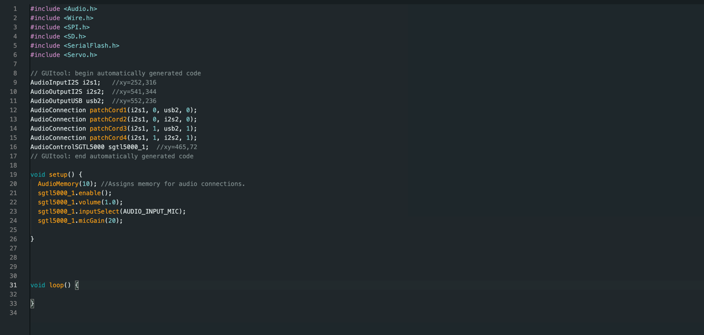

I then changed the USB type to Serial + MIDI + Audio. This allows these different types of data to travel through the USB connection. I did not need MIDI data but there was no Serial + Audio option. Upon loading this code into the Teensy with the microphone connected to GND and MIC via hook-up leads, the teensy microphone became accessible on my computer as an input.

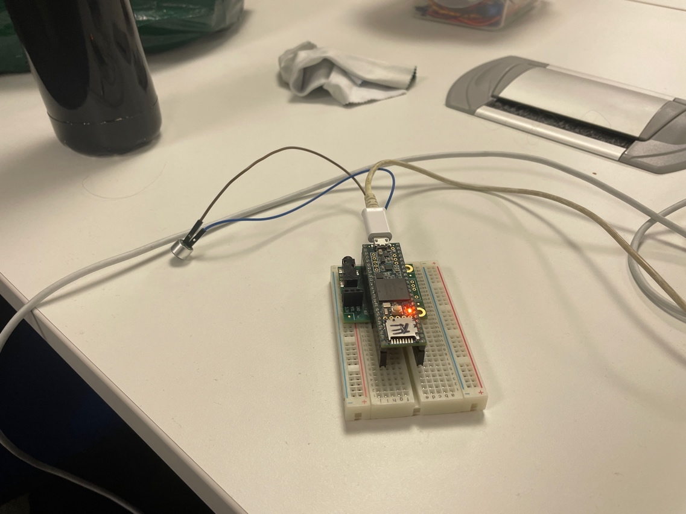

Next, I started to think about set-up as a whole and signal routing. I decided I would use 4 Shure SM57’s for the outward facing directional microphones, the fact they are all the same is good as it allows uniformity in frequency response. Shure SM57’s are Dynamic microphones; I chose them for this fact because dynamic microphones are quite hard to damage. Working with feedback can cause accidental extremely high sound levels. Using a condenser microphone in a situation like this could break it. To get the signals from these microphones into my computer, I decided to use a Zoom F4. This is typically a field recorder however it functionally can be used as an audio interface. This is a good choice because it is light and allows me to move and set-up RIFS faster. Upon testing out the Zoom F4 (with microphones plugged in and USB running into my laptop) I wasn’t receiving any signal. I researched into Zoom field recorders (https://www.youtube.com/watch?v=M0KpdFp4qZU) (Accessed: 1 December 2022). I realised I had to prime the device for use as an Audio interface. Entering settings – USB-Audio Interface-Multitrack Audio. This worked and I received audio into Logic however I soon noticed that I had to exit and re-engage this mode if I ever had to reconnect the USB.

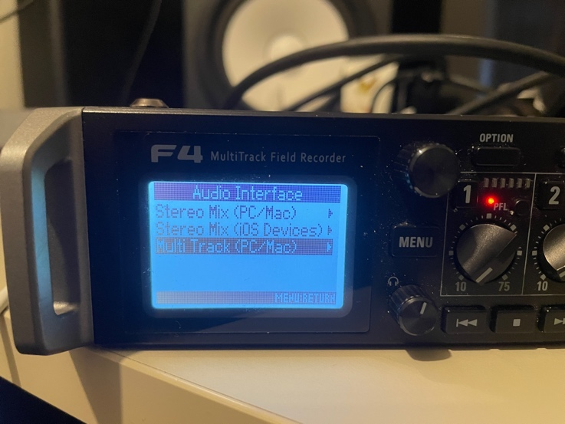

Because of needing inputs from the Zoom F4 and the Teensy microphone in Max/MSP I needed to create an aggregate audio device to combine them as it is not possible to select multiple audio devices in Max/MSP at one time. I attempted to do this in the Audio MIDI Setup however when I selected the Teensy as one input the option to add the Zoom F4 was removed. To bipass this, I routed the Zoom F4 inputs through Logic Pro X and subsequently Blackhole which I could select (all channels require to be primed to record in Logic in addition to input monitoring selected).This aggregate device ‘Testing Device 5’ combined the Teensy Mic input (Inputs 1/2) and the Zoom F4 inputs (four directional microphones) (Inputs 3-6). I then opened Max selected the aggregate device as the input device and tested each channel independently. I tested each channel independently using the ‘adc~’ object in a chain with ‘gain~’ and ‘dac~’ objects. The signals were output out of my laptop speakers. Also, to note, on the Zoom F4 and in Logic gain was turned to a maximum for each channel I thought this would add some interesting distortion into the feedback loop.

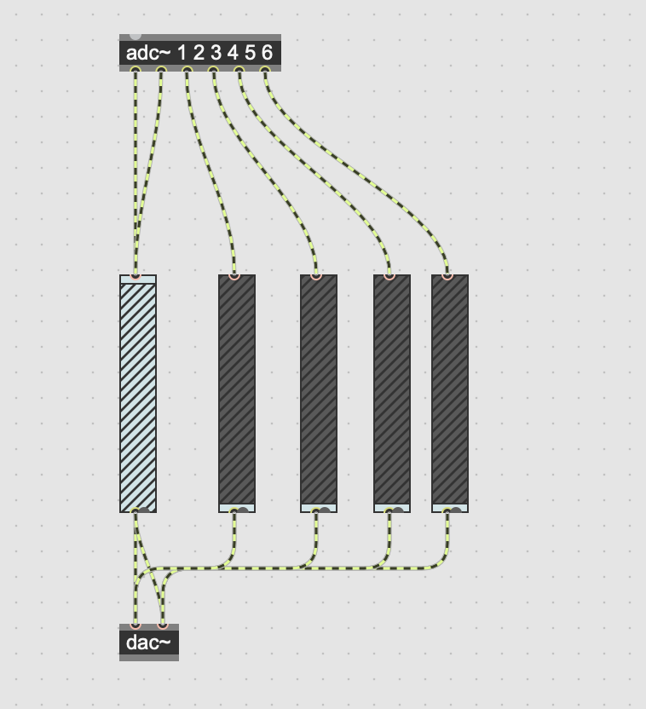

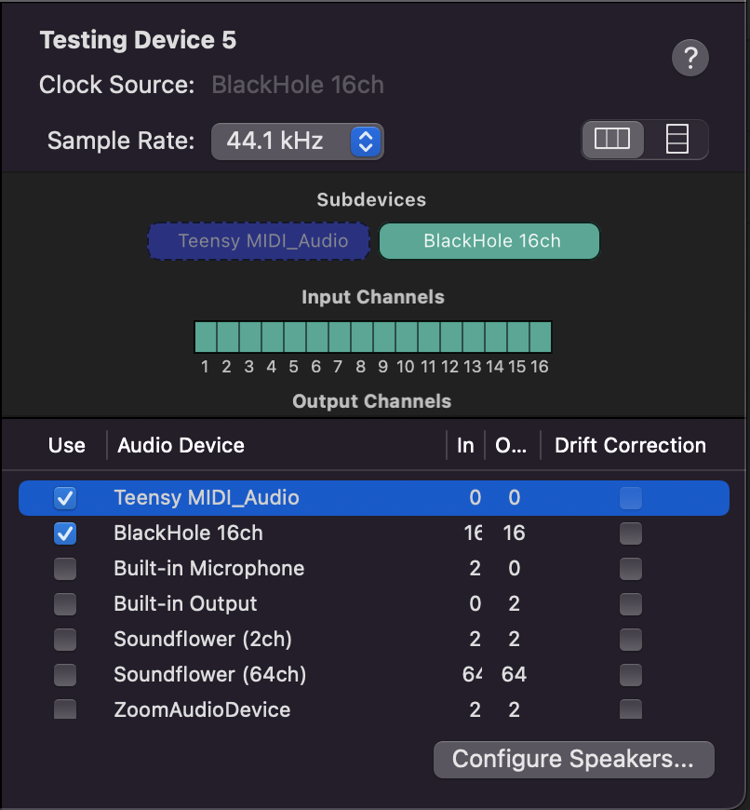

Next, I set-up the speakers in my required configuration (each microphone was placed to the right of its respective speaker), connected them to the Scarlett 6i6 (1-4) outputs and connected this to my laptop. I conducted similar testing independently on each speaker.

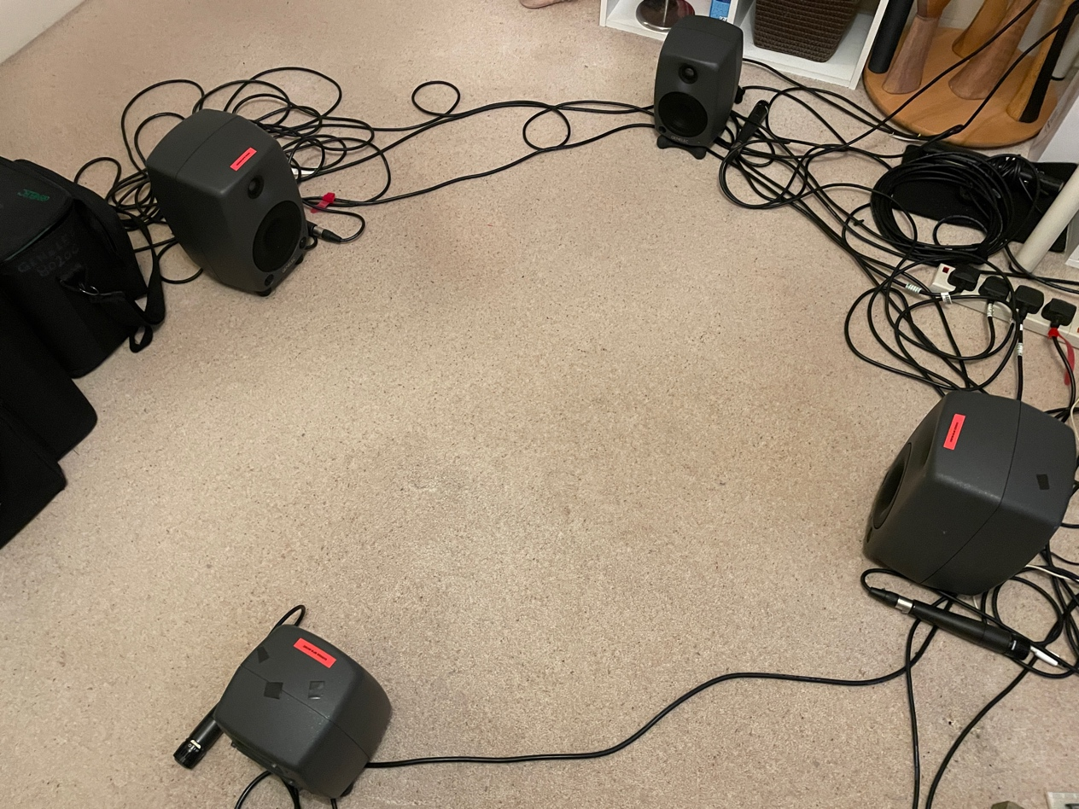

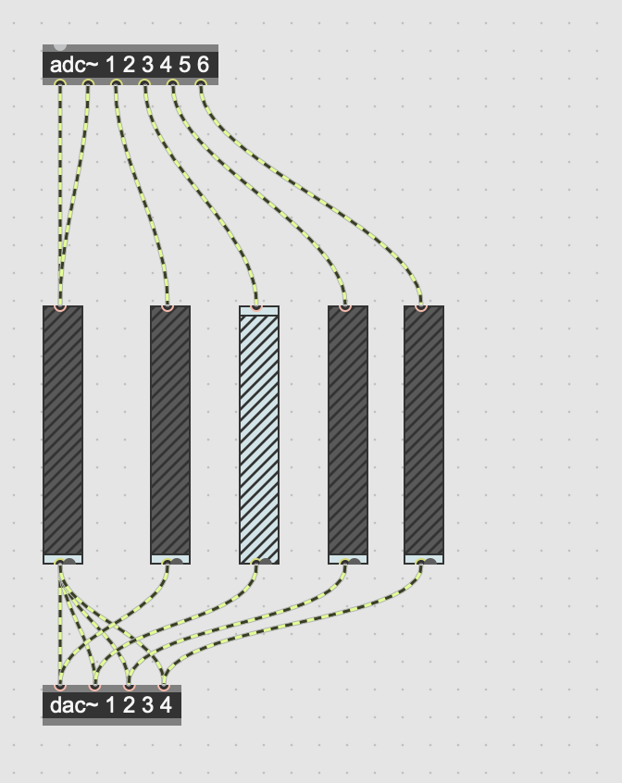

The patch above shows each directional room microphone inputs 3-6 being routed to a speaker outputs 1-4. The teensy microphone is output through all of them. Below is a full equipment list for RIFS

**RIFS Equipment List**

* 4 x - Shure SM57 Dynamic microphones
* 4 x – XLR Cables
* 1 x – Zoom F4 Field Recorder
* USB 2.0 A-Male to Mini-B Cable
* MacBook Pro
* USB A-Male to USB-C Cable
* Scarlett 6i6 Audio Interface
* Genelec 8020C (Pair)
* Genelec 8030 (Pair)
* 4 x – XLR (M) to 6.35mm (¼ Inch) Mono Jack Cable
* Teensy 3.6
* Bread Board
* 2 x Servo Motor SG90
* Teensy Microphone (PUI Audio part AOM-6738P-R)
* Flexible Metal Frame
* Wire Twisted Arm
* 10+ Hook-up leads
* Micro USB Cable
* Gaffe Tape
* Electrical Tape
* Twist Ties
* 2 x – Plug extension leads

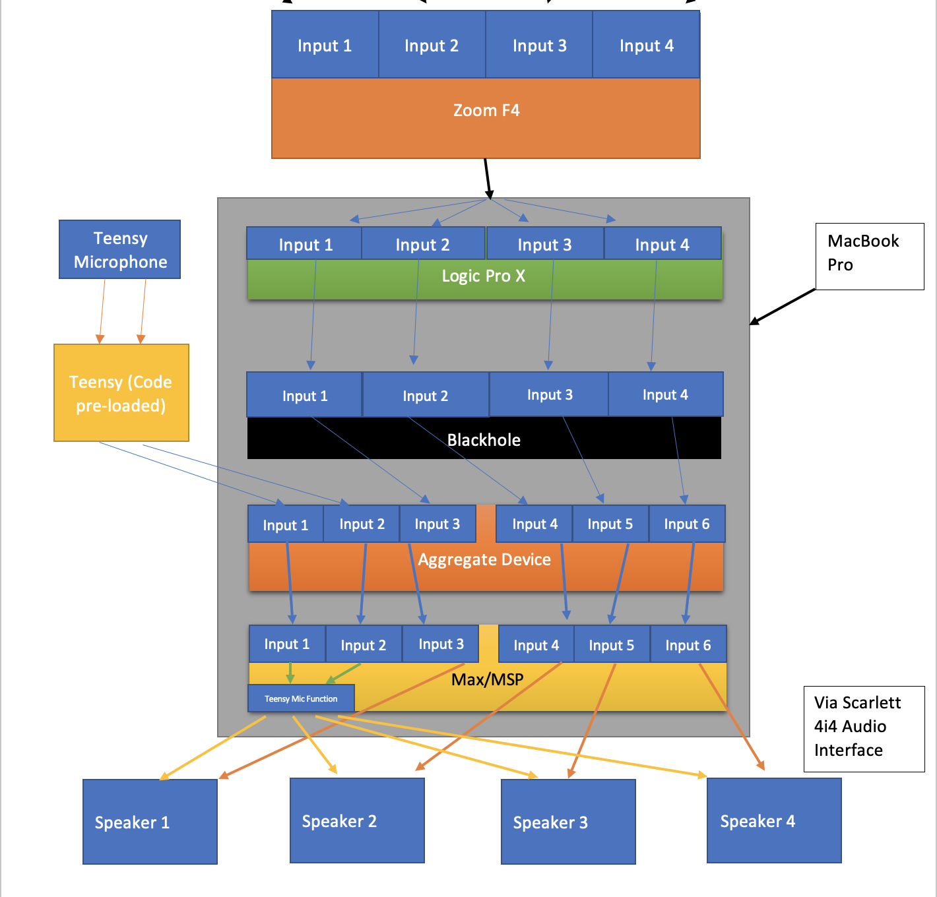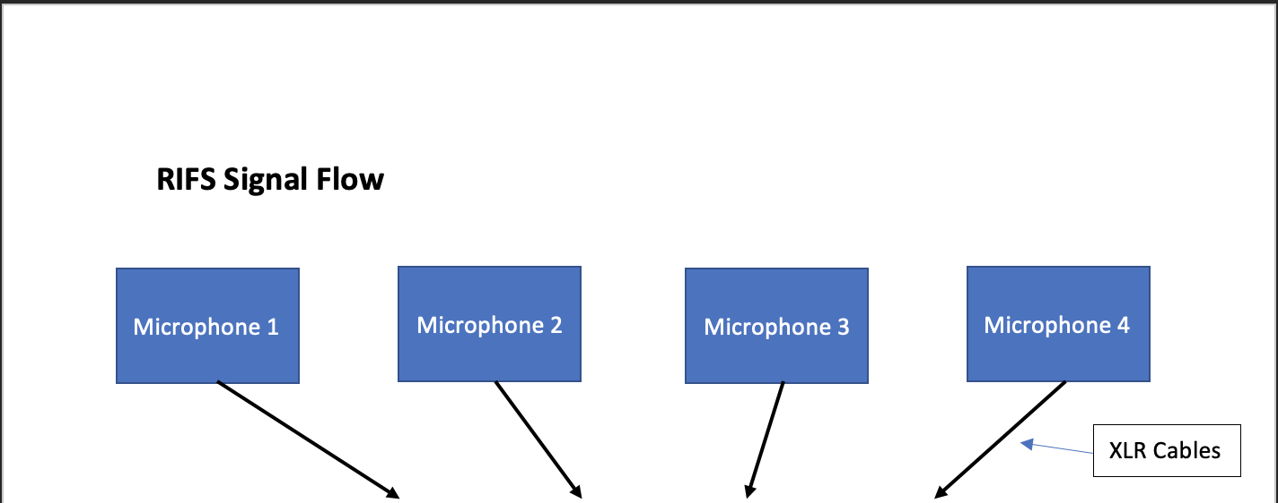

**Week 11**

Now that I had all the inputs required into my Max patch, I next needed to add the functionality to identify the microphone recording the largest sound level at a given time. For this I fed each of the directional microphone signals into a ‘levelmeter~’ object and outlet this into a ‘number’ object. This ‘number’ object displays an integer value of its related microphones observed sound level. However, upon testing I found this number to change too quickly. I wanted the number to be somewhat of an average because I didn’t want momentary anomalous volume spikes to impact my system. However, this averaged period must be fairly short because generally one instrument or sound in a room will be louder than the others. Therefore, measuring average level over a longer time would produce undynamic results. Through some research, I realised I wanted to identify rms values.

<https://cycling74.com/forums/peak-and-rms-mean-values-incoming-signal>

(Accessed: 6 December 2022) Indicated I could potentially look at the average~ object.

Through research on the ‘average~’ max help page I found that the object has a rms mode which simply needs to be banged into the object in a message.

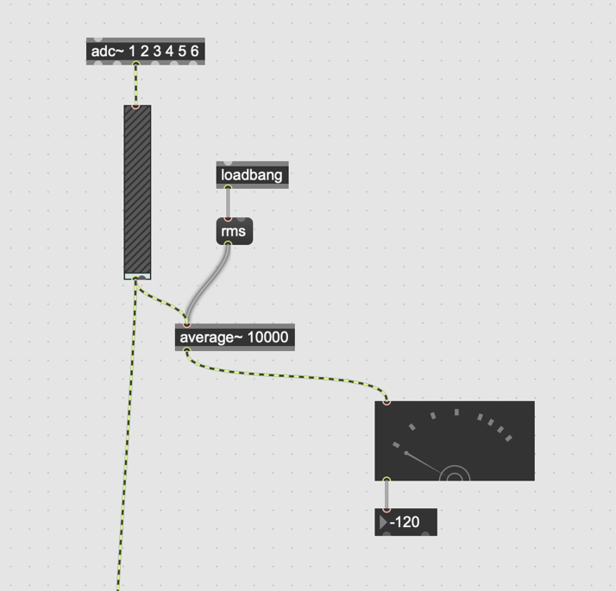

The image above shows how this was implemented for one channel. ‘loadbang’ object bangs through the ‘rms’ message into the ‘average~’ object. This puts ‘average~’ into rms mode and is automatically banged through upon loading the patch. The number box at the bottom shows the sound level currently ‘-120’. I applied this to all four directional microphone channels.

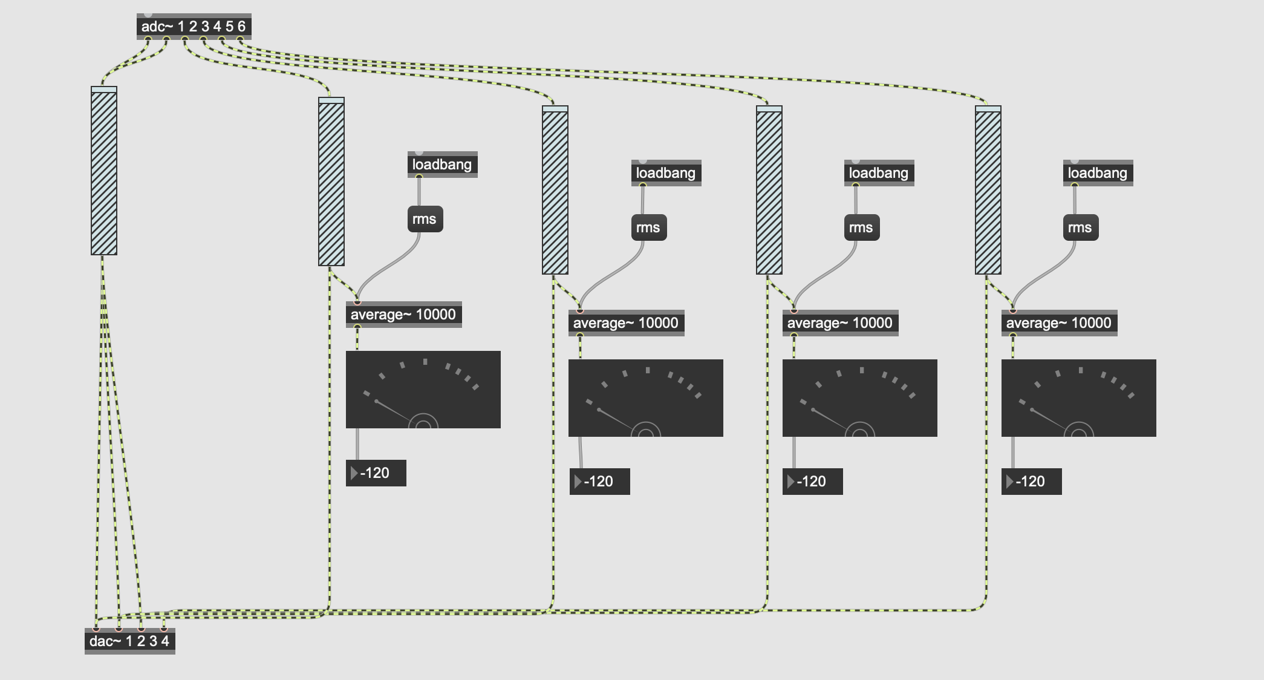

My logic for the next part of this problem was as such; put all these sound level values into a list, put the largest value into a separate message box, find the position(index) of that value in the list and that will identify the microphone. To identify the largest value, I used a series of if statements. The if statements determine the largest value out of microphones 1 and 2, the largest value out of microphones 3 or 4, then if the largest out of these two remaining. It outputs the largest value in total.

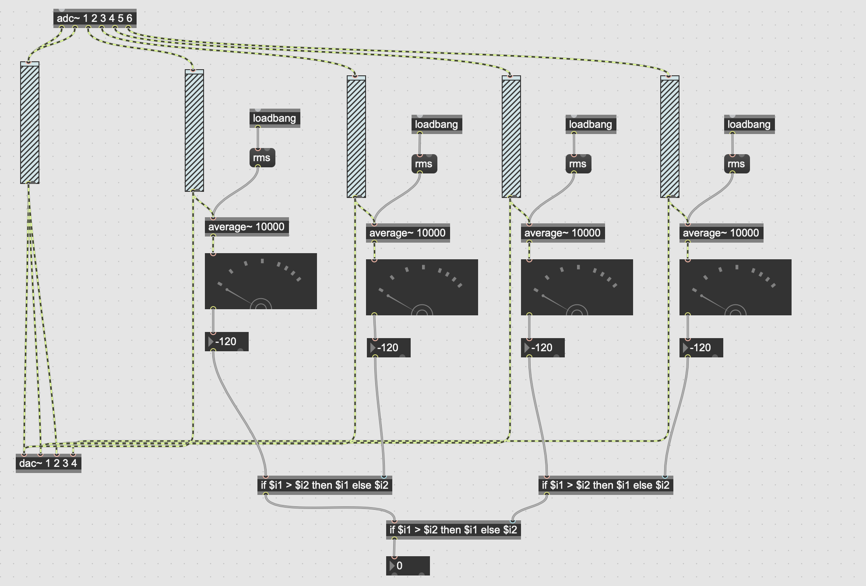

Each conditional if else statement acts to only output the largest of the two inputs.

I identified that the ‘pack’ object would be useful for creating lists.

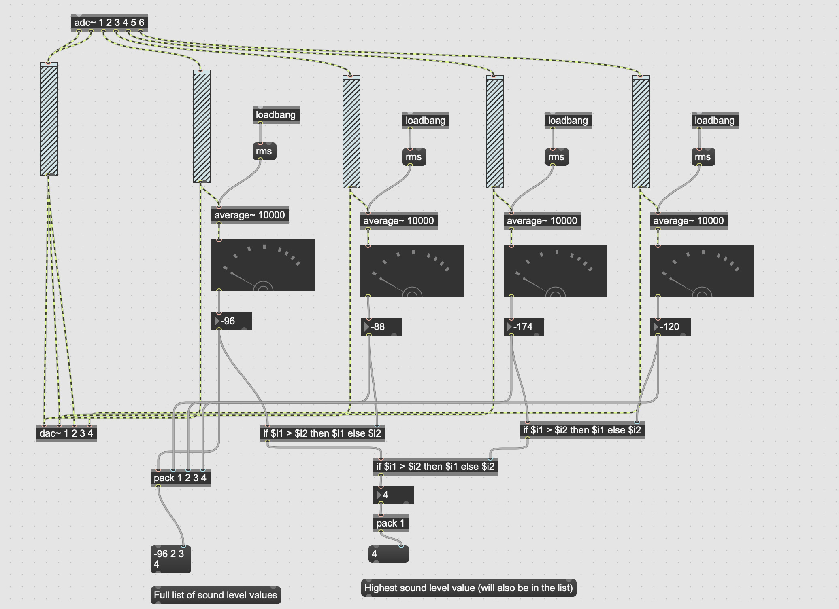

However, this only creates a list once. A bang is needed into the first inlet of the lists message box to reform the list. As I’m going to be needing to receive new at data at consistent intervals, I knew I would need to create a clock function sending bangs out at consistent intervals.

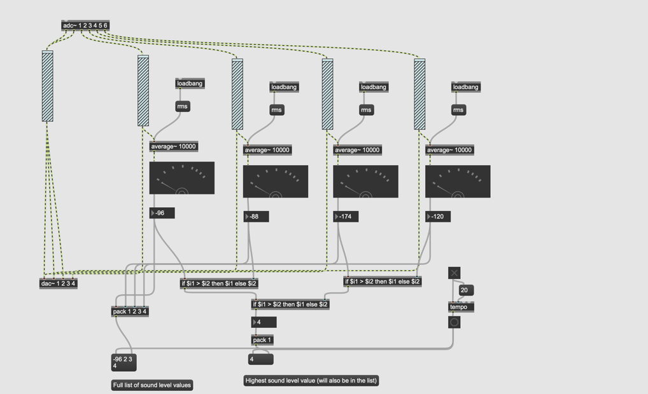

I added that in using a ‘tempo’ object with a 20 BPM control. This I tested was a good speed to generate new positions. Also, I included a toggle. This will allow me to stop the robotic arm moving as new sound levels won’t be processed into lists and therefore new positions won’t be generated. This is important functionality to be able to stop all robotic movement very quickly to limit damage if RIFS is in a precarious position or a connection comes lose.

After this I researched and found ‘zl sub’ obeject for finding index of item in list <https://cycling74.com/forums/finding-the-index-of-an-item-in-a-list> (Accessed: 7 December 2022).

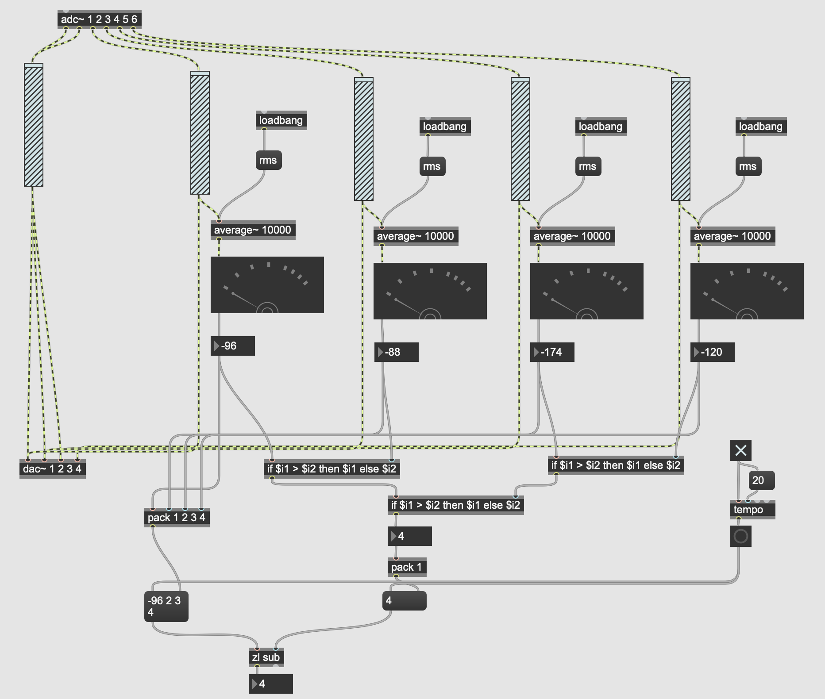

The left inlet is used to input the list and the right inlet is used to input an item in the list that you want to find the index of. The output of ‘zl sub’ object is my loudest microphone number ‘4’.

Next, I need to get this number onto the teensy. The output of ‘zl sub’ an integer 1-4 needs to be sent to the teensy which will move the robotic arm depending on which number is received. The serial port can be used to send data between Max and Teensy.

I set up an initial simple test to get a signal banged through the serial port. This test was that if a three is banged through the port the LED on the Teensy lights up. It was necessary to have some sort of test reaction using the Teensy because it is not possible to view the serial monitor while sending through the serial port in Max.

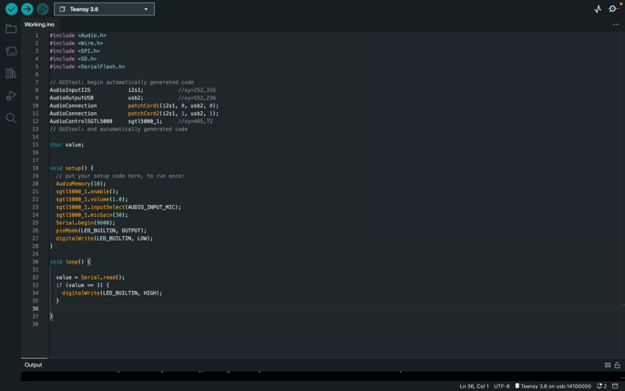

Arduino IDE code loaded onto Teensy

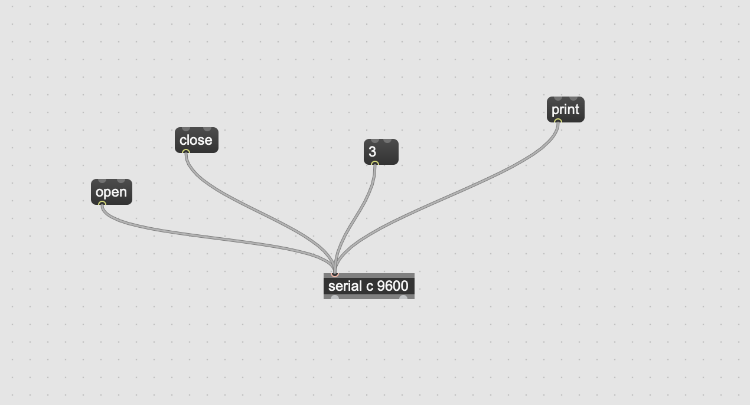

Banging through ‘close’ then ‘open’ message to ensure serial port is clear. Banging through ‘print’ was used to identify which serial port the Teensy was on ‘c’. Then ‘3’ was pressed and Teensy LED activated.

Now this was working I added this functionality into my RIFS patch and extended my Arduino code to include servo movement.

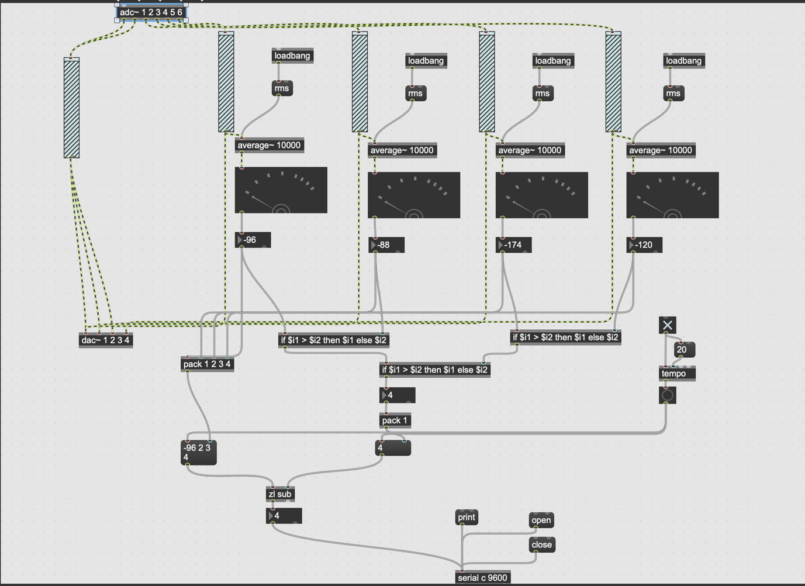

I merged this serial port test Arduino code with code in which I tested the two servos simultaneously. I then extended this to include my logic…

Initially upon receiving a new position to action from Max/MSP Servo2(‘myservo2’) moves to a neutral 12 o’clock position or 90°.

If the new position is 1 or 3, Servo1(‘myservo’) moves (or stays at) to 0°.

If the new position is 2 or 4, Servo1(‘myservo’) moves (or stays at) to 90°.

If the new position is 1 or 2, Servo2(‘myservo2’) moves to 0°.

If the new position is 3 or 4, Servo2(‘myservo2’) moves to 180°.

I kept the code simple; each microphone position has a separate if statement that runs and moves the servos to that position. There is a 200ms delay before Servo2(‘myservo2’) moves from the 90° (12 o’clock) neutral position to 0° or 180° this is so it has time to reach this neutral position before moving.

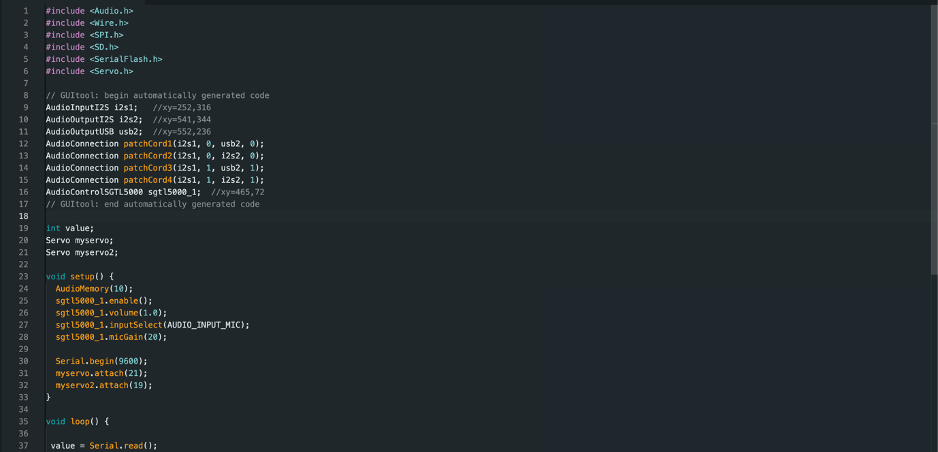

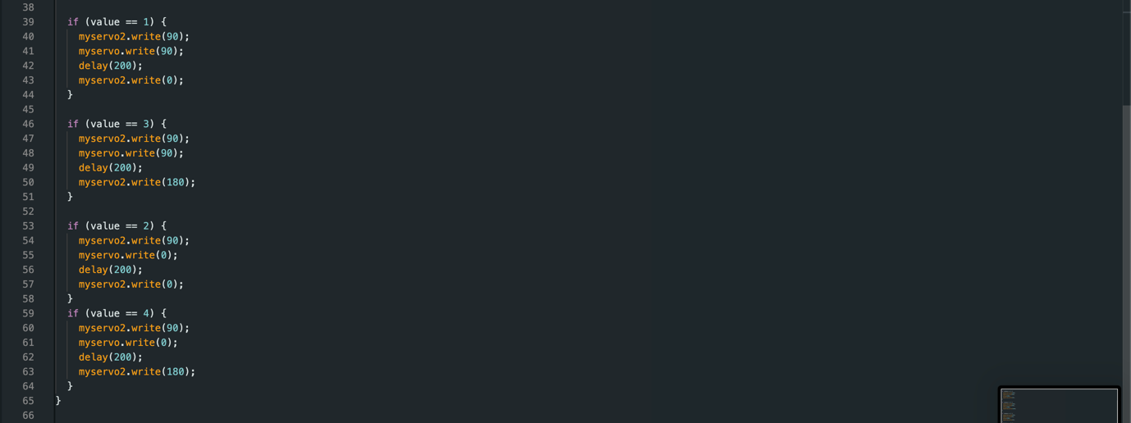

I uploaded the code to my Arduino and ran some tests through Max however I wasn’t getting any movement in the servo’s. I looked at the Max Console to see what was being banged through the serial port and I realised the output from ‘zl sub’ was continuously being banged through the serial port. Because it kept sending a new message, I think this was clogging up the serial port. I needed only one bang when a number was output from ‘zl sub’, for this I added in a ‘change’ object which removes any repeated numbers. It only bangs through when the number changes, this was exactly what I needed.

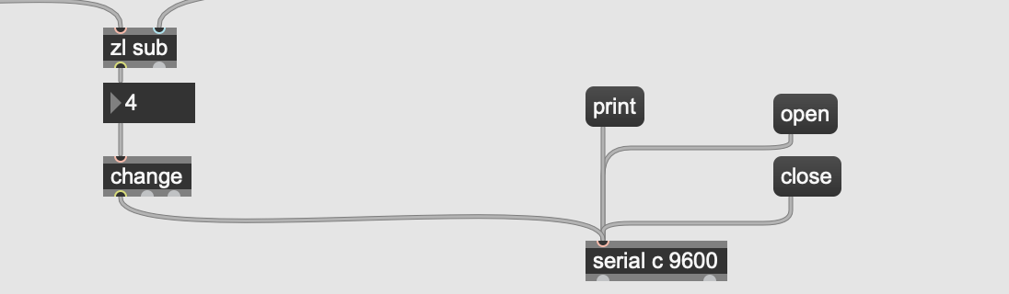

Upon various testing, this worked. Different positions were banged through the serial port and this moved the servos as required and expected.

**Week beginning 19 December**

Now that the software and servos were working as intended, I needed to incorporate them to create the moving structure/arm. First, I superglued Servo1(myservo) to a small wooden block that I would use as a base. I then tried to superglue the wire frame to the servo however after holding it in place for a while, it wasn’t sticking enough. After experimenting with a few different options such as cable ties, tape etc. all of which didn’t secure the structure tight enough, using pegs with superglue inside worked. The pegs secured the wire to the servo arms and the superglue solidified this. Next, I connected the top Servo2(myservo2) and flexible twisted wire arm to the wire frame using gaffe tape. Video on the right shows testing.

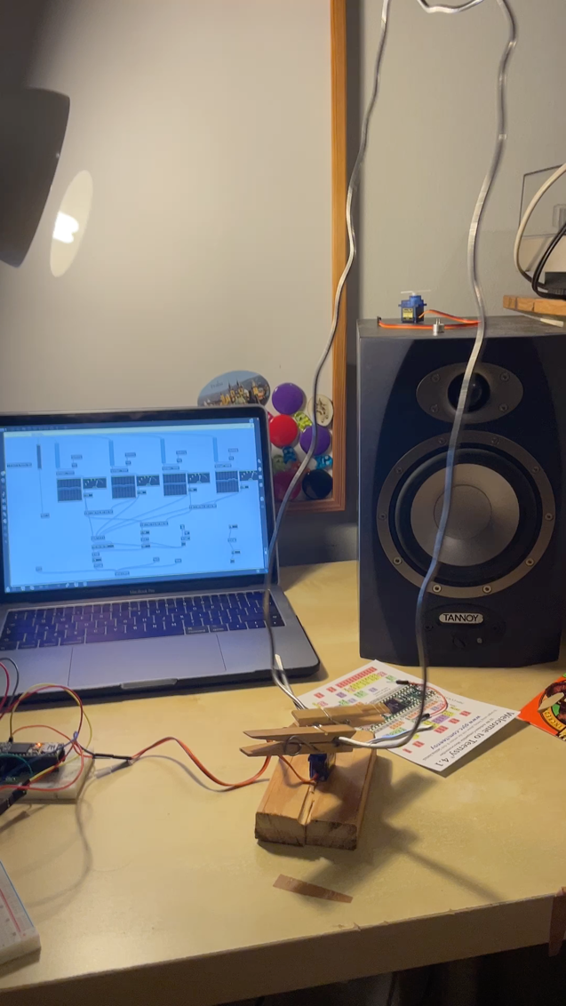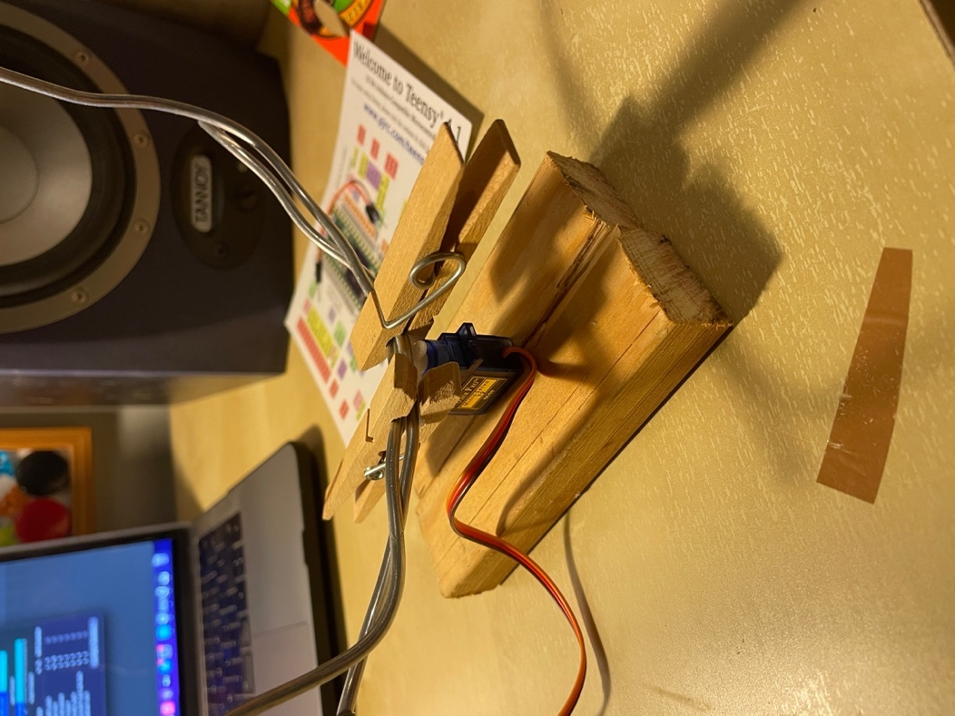

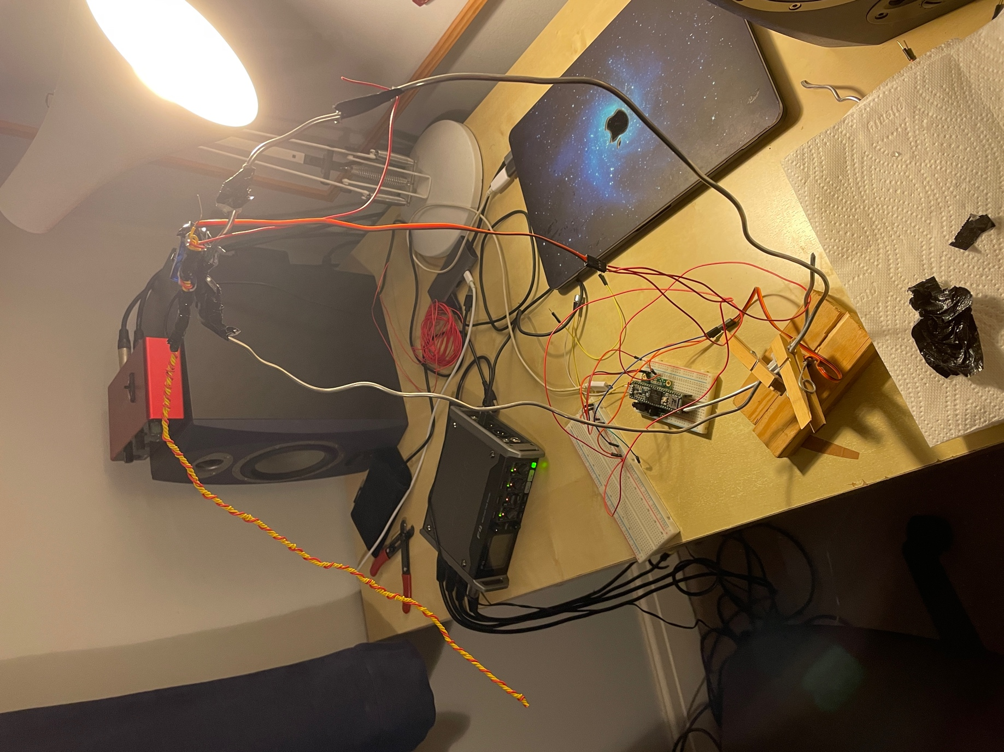

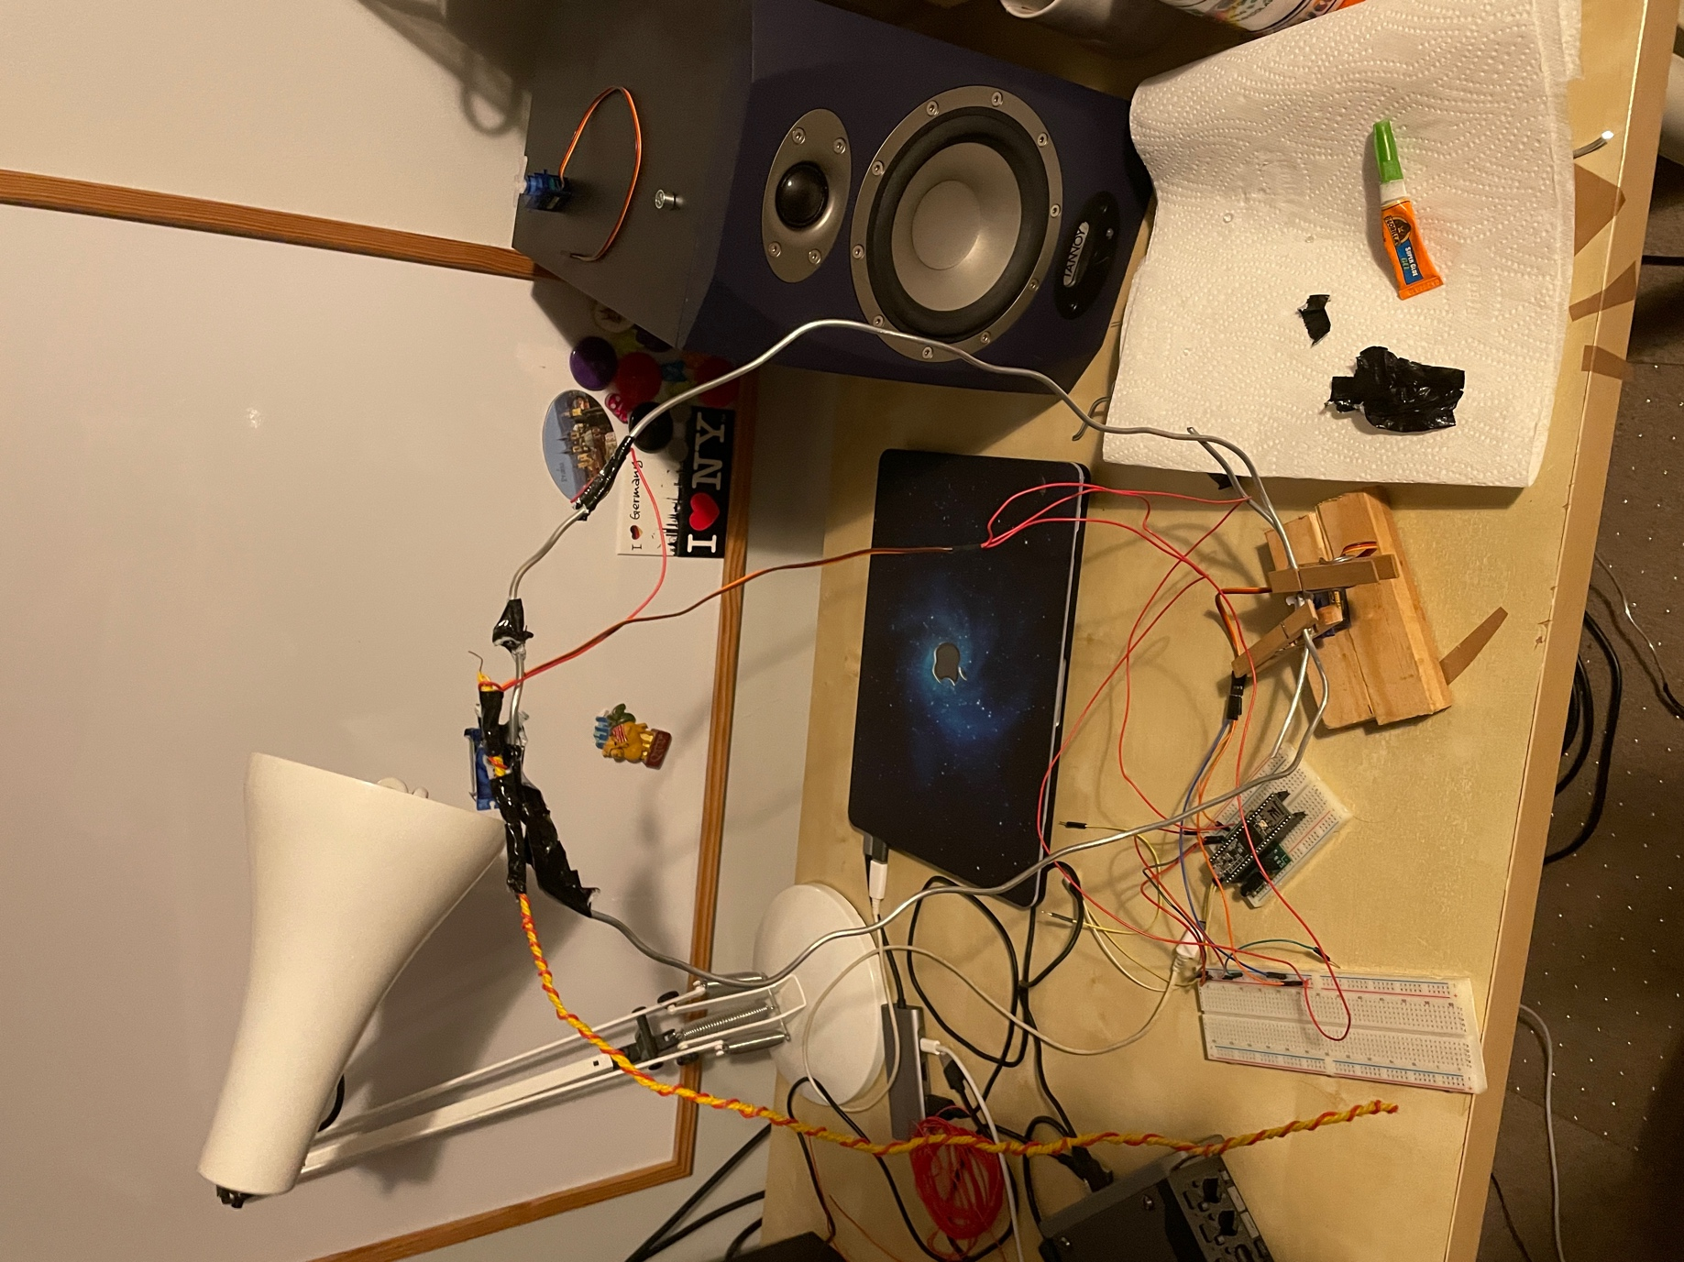

On a new day I loaded up Max and Arduino to carry out further testing. However, I kept receiving signal hang-up errors when attempting to upload my code onto the Teensy. Through research and intuition with the progression of my project, I thought this could be linked to the data being banged over the serial port. Trying to isolate the problem confirmed this as the Arduino code loaded onto the teensy without problem when Max was not open. This was an issue with the order in which I loaded the programs. Logic must be loaded first then Arduino and the code uploaded to Teensy, only then should Max be opened. I came to this conclusion through experimentation and logically thinking through the signal flow. Also, it is needed to close and then reopen the serial port in Max on each loading of the program. If issue with signal hang-up check the ports in Max by banging through ‘print’ message, had said before my fix ‘specified port not available’.

**Friday 23rd December**

Now that I had the frame and Servos in place for RIFS creating the moveable arm which I had tested at all different required positions 1-4 vigorously, the next stage was to add the teensy microphone into this system. Prior to this I had a microphone connected to the teensy, not integrated into RIFS, via short cables to allow me to continually test that this microphone functionality is working throughout continuous progressive integrations of the software and hardware elements of RIFS.

I connected the microphone to the end of the more horizontal arm section of RIFS via a series of hook-up wires which looped around the already present twisted wire coil. I secured any wires together using electrical tape and twist ties.

Upon my next testing of RIFS I was impressed. The lack of tension in the lightweight hook-up wires connecting the microphone to the wire coil arm as expected create a genuine projectile motion in the microphone. This being said, I noticed that the momentum generated from some of these movements at times made RIFS unstable or even fall over. To counter this issue, I decided I needed to increase the weight and surface area of the base to lower the centre of gravity of RIFS. I glued the previous wooden base onto a larger, thicker, and heavier base. This completely fixed the issue. Additionally, I tested in Max/MSP so that after integrating the microphone into RIFS I was still receiving its signal as intended.

**Saturday 24th December**

Now that I had the core robotic elements of RIFS working as intended, it was time for me to combine it with the static elements of the system. I placed the robotic arm in the centre of speakers and microphones set-up ensuring each speaker and microphone channel were the same as the positions assigned in RIFS. For example, the area the microphone moves to when sent position 2 is a speaker connected to output 2 and a microphone connected to input 2. This is important for clarity in problem solving and defining signal flow.

The setup worked like this. The microphones were connected via XLR to the Zoom F4 which was connected to a MacBook. I sent these signals into the audio routing software Blackhole via Logic Pro X where all channels were record ready and input monitoring selected. An aggregate audio device was created using Inputs 1 and 2 from the teensy microphone and then inputs from blackhole (the static microphones) as 3, 4, 5 and 6. This aggregate device was necessary as Max/MSP does not allow the functionality to select more than one audio device, something vital for RIFS. Max then used this Aggregate device (Testing Device 5) as an input and the Scarlett 6i6 as an output device, outputs 1-4 on the 6i6 corresponded to a different speaker and RIFS position. I again tested elements separately using simple tests for example outputting saw waves through each of the speakers independently to check all the hardware and signal routing was working as intended before bringing all the elements together.

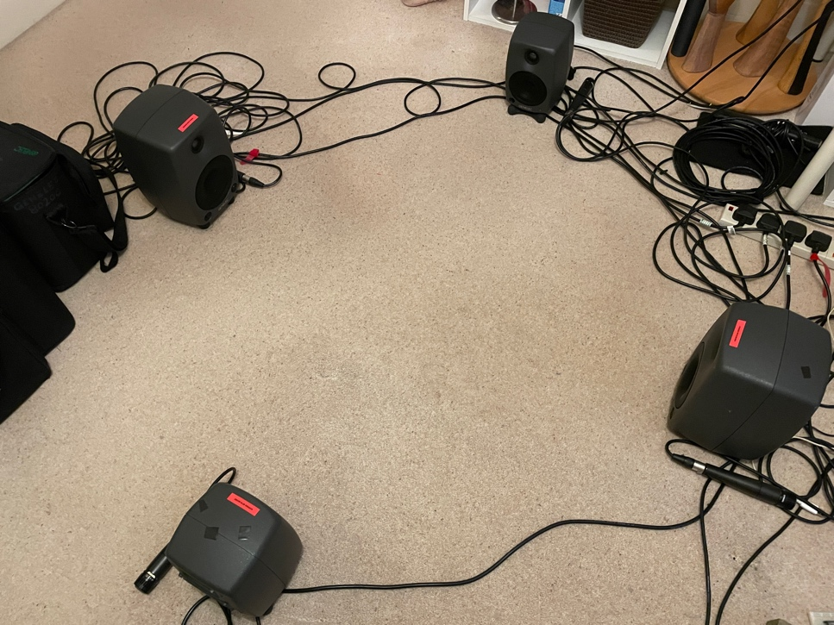

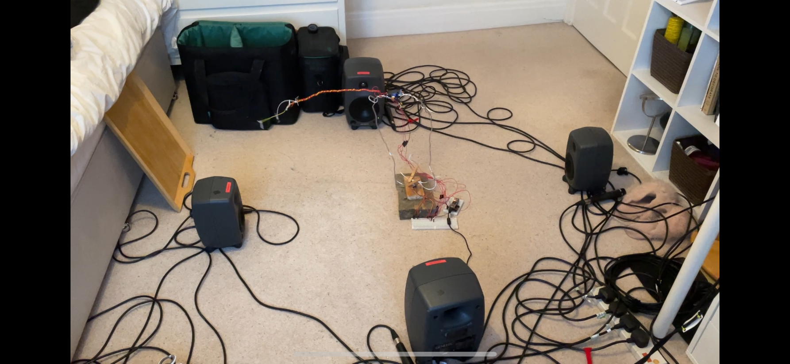

Now I had my first fully functional version of RIFS. Below is the Max patch.

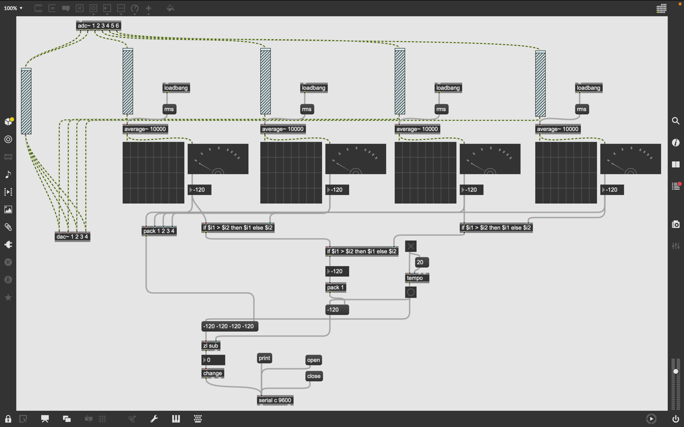

I tested this and it worked however there are still a number of things I need to do to make the system interestingly musically. Firstly, I decided I only wanted the Teensy microphone to be output from the respective speaker that the microphone/arm was positioned nearby. In the tests the impact of the microphone on the floor was all encompassing and I thought an interesting way to change this would be to direct it out of a signal speaker therefore omitting these sounds in one direction only, this in itself will create interesting spatialisation and hopefully create more dynamic interactivity with other robotic instruments listening in the space.

I wrote and tested the code below. What is important is the addition of the encapsulated ‘Teensy Mic’. The first inlet into this sub patch sends data from a dial which is then used to control a volume slider for all the potential Teensy Mic signal paths. Inlet two is used to input RIFS position. The sub patch code then uses if statements with bang else zero to create a binary logic. Only if the RIFS position is the same as the speaker number will the ‘adc’ object be turned on and the signal flow out the respective output to the related speaker.

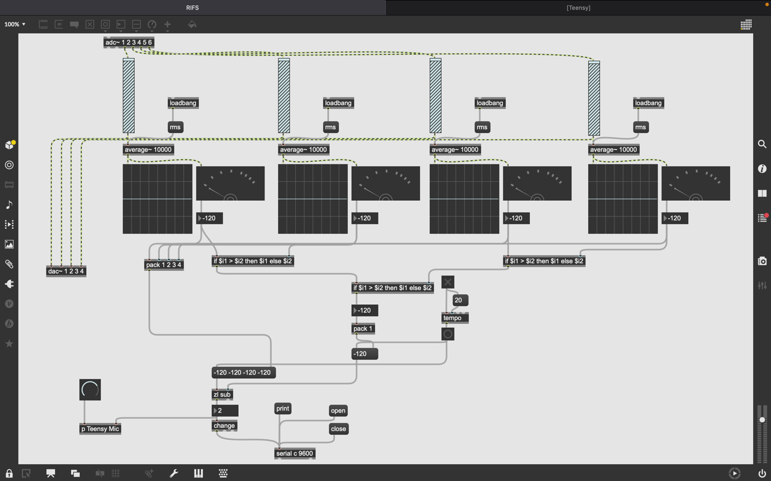

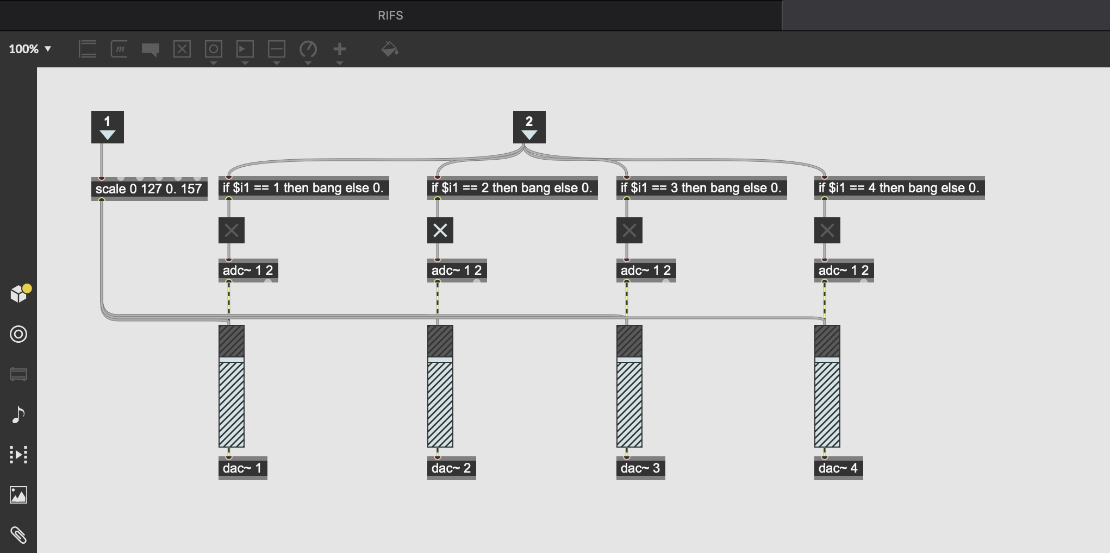

Despite the logic being correct, upon testing I had issues with the audio turning off as the RIFS positions changed. Max doesn’t like switching between inputs and outputs whilst running. I decided to bi-pass this issue without completely re-writing my code. Instead of turning inputs on and off I would keep them all running and use the If statements to turn up the gain on one channel at a time keeping the rest muted. What I changed the code to is shown below. The ‘*~’ object multiplies two signal together, thus allowing me control of the amplitude/volume of the signals via the dial in the main patch.

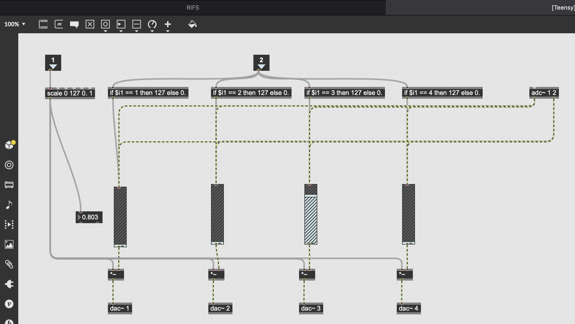

This fix worked very well.

**Wednesday 4th January 2023**

I came back from small break on the practical side of this project. I loaded up the programs in the correct order and tested it out. The first issue I realised, which was a problem before which I had not gotten round to yet related to the affixation point of the top arm servo and the metal wire frame. I had previously connected these two together with gaffe tap however the servo kept tilting forwards off axis. This caused a problem as due to the angle the different speaker positions wouldn’t be reached by the microphone properly. To fix this I removed the servo and using some excess metal wire built another part to the frame which the servo could sit on, and I could fix more easily to using gaffe tap. I connected the additional frame to the main frame by twisting it round it. I then connected the servo to it using gaffe tap, this massively fixed the problem, the servo didn’t tilt any longer.

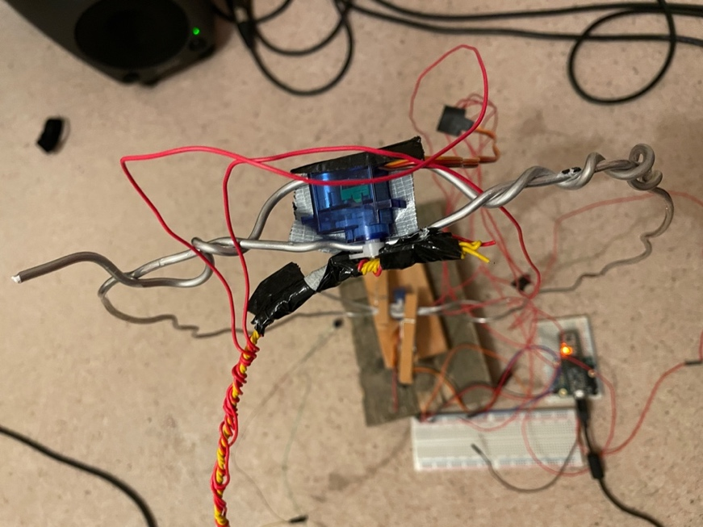

This picture was taken before I fully twisted around the left side of the additional wire frame.

The next issue I had was that I realised the primary microphone was not working properly. I was getting some sound out of it, but it was cracking, buffeting kinds of sound. I methodically isolated the problem as the microphone. Upon inspection, I realised the solider points between the Mic and GND pins where connecting.

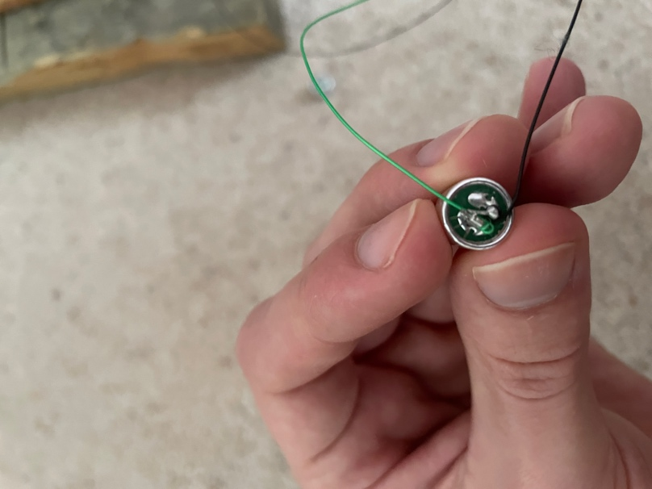

I trimmed down the soldier connecting which fixed my problem.

Now that the base of RIFS was working, I started towards the more advanced programming elements. As stated much earlier in this journal, RIFS needed to have the functionality to quell feedback and break up its characteristic exponential increases in sound level. I already had the idea that the program could pull down the each of gain sliders to cut off these self-propelling increases in sound level, momentarily breaking these exponentially increasing loops.

This functionality was encapsulated in a sub patch named ‘Safety Protocol’. 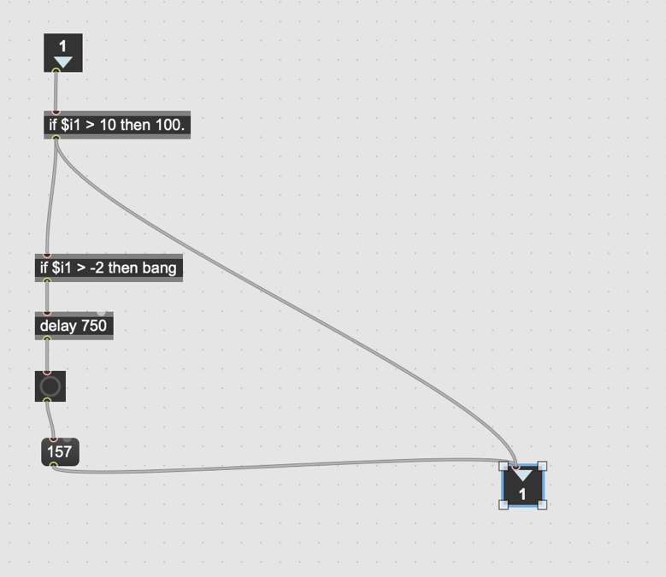

The first version of the sub patch is shown to the left. Inlet is the sound level number for a specific microphone. If this is above 10 then ‘100’ is banged through to the gain slider for that microphone signal chain. This lowers the volume. If this occurs a bang is triggered which after being delayed for 750ms triggers ‘157’ to be banged through to the slider. The slider is back at its normal maximum value (all sliders are turned to maximum upon loading).

This worked and did a very effective job at stopping these harsh peaks occurring. However, I felt like it muted it too much, it was not in the creative sweet spot which I desired. I had the idea to include another delay before ‘100’ was banged into the gain slider to allow the feedback to ramp up even more before the gain was reduced. Below is the final version of this function.

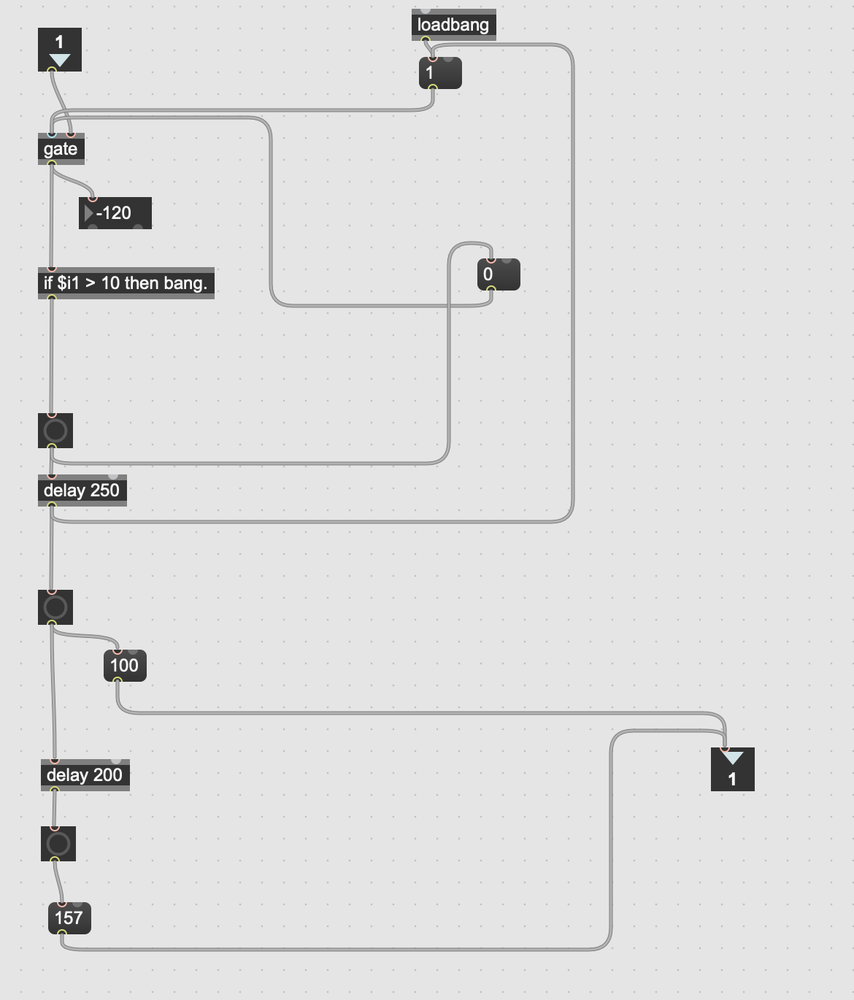

The outlet and inlet are the same however I’ve included a gate, added another delay, and much shortened the previous delay to 200ms. Initially I added in the other delay (‘delay 250’) which would hold the bang for a quarter of a second before sending it through triggering the slider to be reduced to 100. However due to the fact multiple bangs were sent as the input was larger than ‘10’ the delay kept getting re-triggered before it could output a bang, for this issue I added the gate. The gate is loaded in mode ‘1’ or open mode and allows signal flow to the if statement below. Once the if statement condition is true (input larger than 10) and the first delay is to be triggers ‘0’ is banged through gate. This closes it ensuring that no other numbers will be tested against the condition of the if statement. Therefore, ensuring the delay is not continually banged and reset. After ‘delay 250’ a ‘1’ is banged into the gate and open mode is resumed. This is because ‘delay 250’ is ready for a new bang. The output from ‘delay 250’ is also used to bang ‘100’ into the outlet and subsequently the gain slider. This also bangs through to another delay ‘delay 200’ which after 200ms banged through ‘157’ into the gain slider. Maximising the gain slider once again. I had experimented with lots of different delay values, and this was the best pairing that created the most interesting sound whilst taming the peaks. Volume is reduced for a lot shorter time than in the first iteration this works much better because it keeps the feedback in limbo only reducing signal gain for very short periods of time.

Initially I had planned to add some other creative coding to make RIFS sound more interesting such as frequency detection and subsequent equalisation (I would have started doing this using ‘fft’ and its related objects) or (ring) modulation. However, on testing I was very happy with the sounds that RIFS was producing as the ‘Safety Protocol’ function was working extremely creatively. I didn’t think RIFS needed any new functions, and I couldn’t see a purpose in adding them. Therefore, I decided against these additions. I thought it would be disingenuous to add in extra unnecessary functions just to evidence my programming skill. Part of computing and art as well is to keep things simple when it is warranted. I think by adding further functions it would have clouded the idea of RIFS.

**Week beginning: 9th January 2023**

I made some final adjustments to the Max patch. In the ’Teensy Mic’ sub patch I changed the scale object parameters to ‘scale 0 127 0. 6’ This means that the dial now is scaled from 0-6. Effectively this increases the volume of the teensy microphone as this value is used to amplify the signal.

I did this because upon testing I felt like the robotic arm and teensy microphone didn’t have enough sonic presence. Increasing the max value to ‘6’ makes it more percussive, something I hadn’t anticipated but which created really interesting sounds.

After that, I recorded a number of demo videos to demonstrate RIFS. The demo examples are taken in two different spaces. RIFS sounds very different in each of these spaces. This shows the impact of environment and acoustics on the sounds RIFS produces.